Chapter 300: Organizational Data

Revision History
Date | Version | Description
4/14/22 | 1 | First Version
4/20/23 | 2 | Second Version
4/11/24 | 3 | Third Version

Contents
Overview 3
Definitions of Data Elements 3
Requirements 5
Entity Types and Responsibilities 5
Accessing the Portal & Browser Requirements 5
Submitter Registration 6
Portal Log In 6
Users Associated with More than One Organization 7
Portal Email Notifications 7
How to Validate Organization Information 8
Identifying Relationships and Required Actions 8
Reviewing Organizational Information 12
Editing Organizational Information 13
Adding, Editing, or Deleting NPI(s) 14
Editing the Primary Taxonomy 15
Adding Practices 16
Deleting Practices 17
Editing Employed or Affiliated Physicians 19
Manually Adding Employed or Affiliated Physicians 21
Bulk Importing Employed or Affiliated Physicians 23
Adding Affiliated Practices 24
Requesting an Extension 25
Final Verification of the Accuracy of the Organization Information 26
Troubleshooting 28
Technical Support and Completion Help 28
Compliance Assistance 28
Appendix 29
Primary Taxonomy Codes and Descriptions 29

Overview
The Maine Health Data Organization (MHDO) is required by Maine law to maintain a useful, objective, reliable and comprehensive health information database that is used to improve the health of Maine citizens and to issue reports promoting public transparency of health care quality, costs, and outcomes. The MHDO makes data publicly available and accessible to the broadest extent, consistent with the laws protecting individual privacy and proprietary information. Acceptable uses of MHDO Data include, but are not limited to, study of health care costs, utilization, and outcomes; benchmarking; quality analysis; longitudinal research; other research; and administrative or planning purposes. As a data submitter, you provide essential data for these efforts.
The MHDO implemented a submission system in 2022 for the collection of Chapter 300 organizational data, previously collected manually via Chapter 630, Uniform System for Reporting Baseline Information and Restructuring Occurrences for Maine Hospitals and Parent Entities. As such, every multi-health system, parent, and hospital shall review and update their organizational information annually via the online MHDO Hospital Data Portal: https://mhdo.maine.gov/hospital_portal/
MHDO Rule Chapter 300, Uniform Reporting System for Hospital Financial Data is available on the MHDO website: Statutes and Rules
This manual provides instructions for how to validate organization data through the MHDO’s Hospital Data Portal.

Definitions of Data Elements
- Address – The entity’s street address, city, state, and zip code.
- Affiliate Of or Affiliated With – A person, organization, or entity who directly or indirectly controls or is controlled by, or is under common control with, the person specified.
- Credentials – The professional credentials of the individual provider such as MD, DO, PA, NP, CNP, DNP, etc.
- Employed/Affiliated Physician – The name of an individual provider that is on the payroll of a hospital or practice, making them employed or affiliated. If an entity has multiple NPIs and a physician has at least one of those NPIs, the physician will get affiliated with the entity.
- End Date – The month, day, and year a physician stopped working at a hospital and/or practice. If a physician is employed or affiliated with multiple hospitals or practices, the end date is unique to each entity.
- Entities – All-encompassing term used to describe health systems, parents, local health systems, hospitals, and practices.
- Fax – The fax number for consumers to contact the entity.
- Health System – Multi-health system that delivers health care services via hospitals, physician practices, specialty care practices, primary care practices, and individual physicians.
- Hospital – The name of the hospital that delivers health care services.
- Local Health System – The name of a system within a multi-health system that delivers health care services via hospitals, physician practices, specialty care practices, primary care practices, and individual physicians.
- Multi-Health System – Multi-health system that delivers health care services via hospitals, physician practices, specialty care practices, primary care practices, and individual physicians.
- National Provider Identifier (NPI) – The unique 10-digit code identified for the entity and individual provider, as enumerated in the National Plan & Provider Enumeration System (NPPES). The relationship between individual providers and an entity is based on medical claims where the individual provider is the rendering provider, and the entity is the billing provider.
- On CompareMaine – Indicates if the hospital or practice is publicly displayed on CompareMaine, the State of Maine’s health care transparency website.
- Parent Entity – An organization that has a controlling interest in another organization.
- Phone – The phone number for consumers to contact the entity.
- Practices – The name of physician, specialty care, or primary care practice that delivers health care services. If an individual physician has incorporated themselves (Inc, LLC, etc.), they may appear nested within a health system, hospital, or practice.
- Primary Taxonomy Code and Description – The primary National Uniform Claim Committee (NUCC) health care provider taxonomy code used by the hospital, practice, and employed/affiliated physician.
- Provider First Name – Individual first name.
- Provider Last Name – Individual last name.
- Provider Middle Name or Initial – Individual middle name or initial.
- Provider Prefix – Prefix to individual name.
- Provider Suffix – Suffix to individual name; used to capture the generation of the individual.
- Start Date – The month, day, and year a physician began working for the hospital and/or practice. If a physician is employed or affiliated with multiple hospitals or practices, the start date is unique to each entity.
- Verified – Indicates that the information for the entity and any affiliated practices and employed or affiliated physicians is correct.
- Website – The URL for the entity’s website.

Requirements

Entity Types and Responsibilities
Practices affiliated with a health system, parent entity, or hospital need to be individually reviewed, edited, verified, or removed.
- Health Systems
  - Review, edit, and validate their organizational information
  - Review the list of affiliated local health systems, hospitals, and practices
  - Review, edit, and validate organizational information for practices that are affiliated with the health system
  - Review, edit, and validate the list of physicians that are employed or affiliated with practices that are affiliated with the health system
  - Add and delete an entity
- Parent Entities
  - Review, edit, and validate their organizational information
  - Review the list of affiliated hospitals and practices
  - Review, edit and validate the organizational information for practices that are affiliated with the parent entity
  - Review, edit, and validate the list of physicians that are employed or affiliated with practices of the parent entity.
  - Add and delete an entity
- Hospitals
  - Review, edit, and validate their organizational information
  - Review, edit, and validate the list of affiliated practices and their organizational information
  - Review, edit, and validate the list of physicians that are employed or affiliated with hospitals and affiliated practices
  - Add and delete an entity
  - Add and delete physicians that are employed or affiliated with hospitals and affiliated practices
Some entities, such as skilled nursing facilities, may be listed as “Optional” in the status column because they are optional to validate based on the current rule, though still helpful to list for relationship purposes.

Accessing the Portal & Browser Requirements
The MHDO Hospital Data Portal URL is: https://mhdo.maine.gov/hospital_portal/
The following is a list of minimum required browser settings:
- Screen Resolution: Optimized for 800x600 or higher
- JavaScript: Required
- Cookies: Required
- Security: SSL/Certificate required for access to restricted resources
- Internet Explorer Compatibility View: Turn Off

Submitter Registration
If you do not know who the pre-registered user for your organization is, please contact the MHDO Help Desk. Additional people who need user accounts for your organization need to be requested through the MHDO Help Desk. Please contact the Help Desk at mhdohelp@hsri.org with this information to set up a new Chapter 300 Organizational user:
- Name
- Company Name
- Job Title
- Email
- Phone Number
- Health System, Parent, and/or Hospital(s) the user is affiliated with

Portal Log In
Existing users of the MHDO Hospital Data Portal (https://mhdo.norc.org/hospital_portal) may use their current username and password to login to the Portal to access the Organization Data. New, pre-registered users will receive a notification email from portal@mhdo.maine.gov with their username and temporary password. If the user account is new, the email will be sent to the address provided during the registration request.
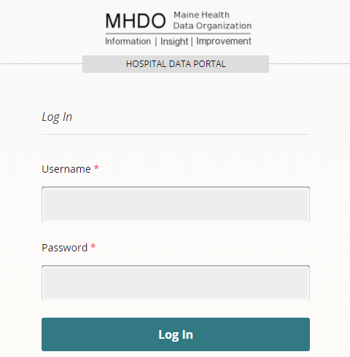
After logging in to the Portal with the temporary password, the user can create a new password by clicking on the username in the upper right corner of the screen, where it reads, “Hello [username]”:
Complete the form by entering the new password, with a minimum of six characters, re-entering the password to confirm the passwords match correctly, and clicking “Change” to save the changes. Once saved, the new password is in effect.
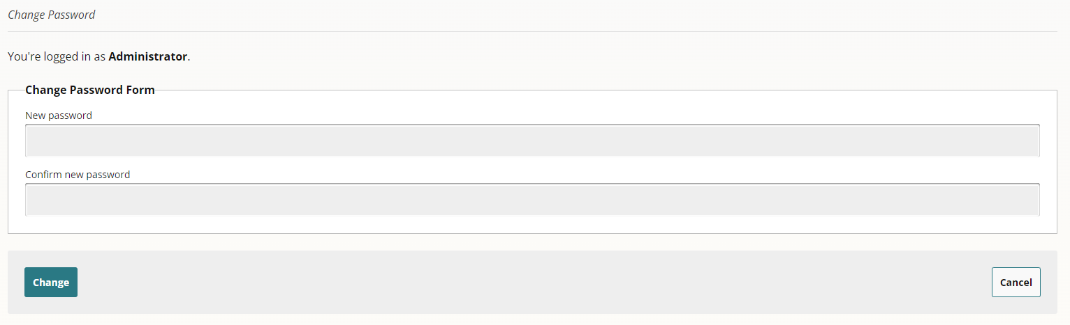

Users Associated with More than One Organization
A single user can be associated with more than one organization in the MHDO Hospital Data Portal. If your user account is associated with more than one organization, you can switch the organization you are viewing by clicking the organization’s name from the Organization Data Home Page. All organizations you are associated with will be displayed and can be selected.
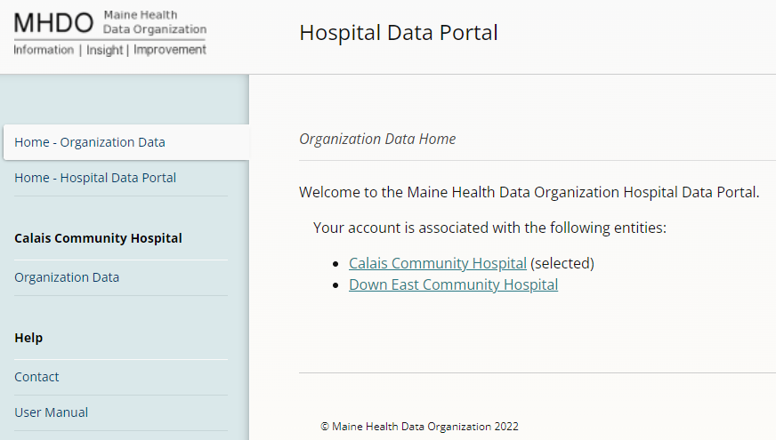
If your user account is currently associated with a single organization but needs to be associated with one or more other organizations, please contact the MHDO Help Desk at mhdohelp@hsri.org with the information below:
- Name (First and Last)
- Organization Name(s)
- Email
- Phone Number

Portal Email Notifications
The MHDO sends notifications to system users (e.g. notifying them of registration and submission deadlines, and late data). All system notification emails will come from portal@mhdo.maine.gov. This is an unmonitored outbound email address and should not be replied to. Instead email the MHDO Help Desk (mhdohelp@hsri.org) with any questions.

How to Validate Organization Information
The features and functionality for Organization Data in the MHDO Hospital Data Portal are consistent, no matter if you are a health system, parent, or hospital user. Practices affiliated with a health system or hospital need to be individually reviewed, edited, verified, or removed.

Identifying Relationships and Required Actions

Home
Upon logging into the Portal, a user will see the Welcome screen, with the “Organization Data” in the left navigation:
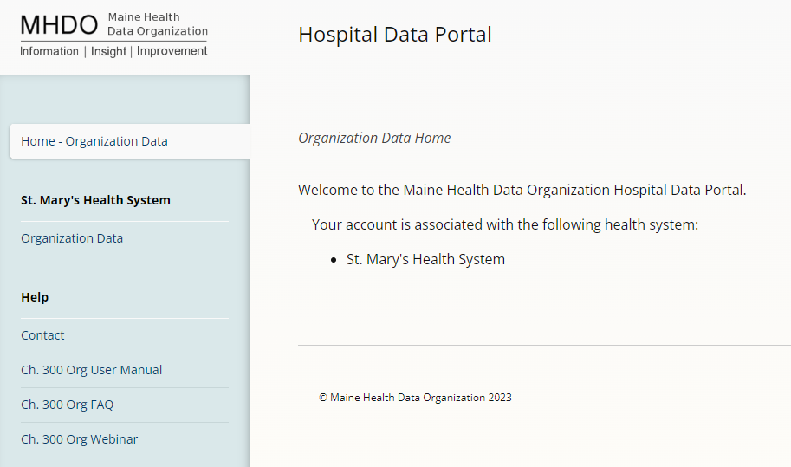

Organization Data
Clicking “Organization Data” will bring users to the main page that outlines the relationships of health systems with local health systems, parent entities, hospitals, and/or practices. To distinguish the relationships among them, the list of entities is indented and a +/- sign appears next to an entity’s name to expand or collapse any affiliated entities. By default, the structure is expanded to show all relationships, statuses, and the current year.
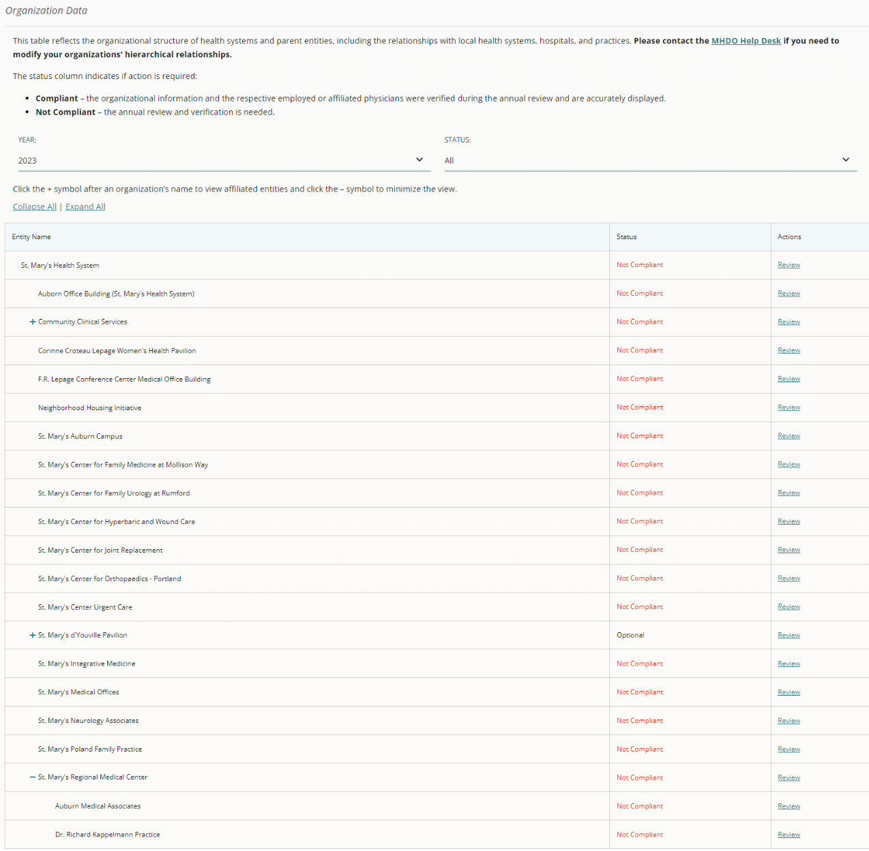
Click the +/- signs next to an entity’s name to show or hide affiliated practices. If a +/- sign doesn’t appear next to an entity’s name, there are no affiliated practices.
Users may use the drop downs to sort by “Year” and “Status” to view the entities that are:
- Compliant – Successfully validated their information
- Compliant¹ – The entity has validated their information and indicated: No MD’s or DO’s are employed at this time
- Compliant² – The entity has validated their information and indicated: We don’t employ MD’s or DO’s at this healthcare setting
- Not Compliant – Need to review and verify their information

If entities are incorrectly associated with one another, please click “Delete” next to the entity’s name and follow the instructions on page 17 to delete practices.
To begin review and verification, click “Review” in the “Actions” column:
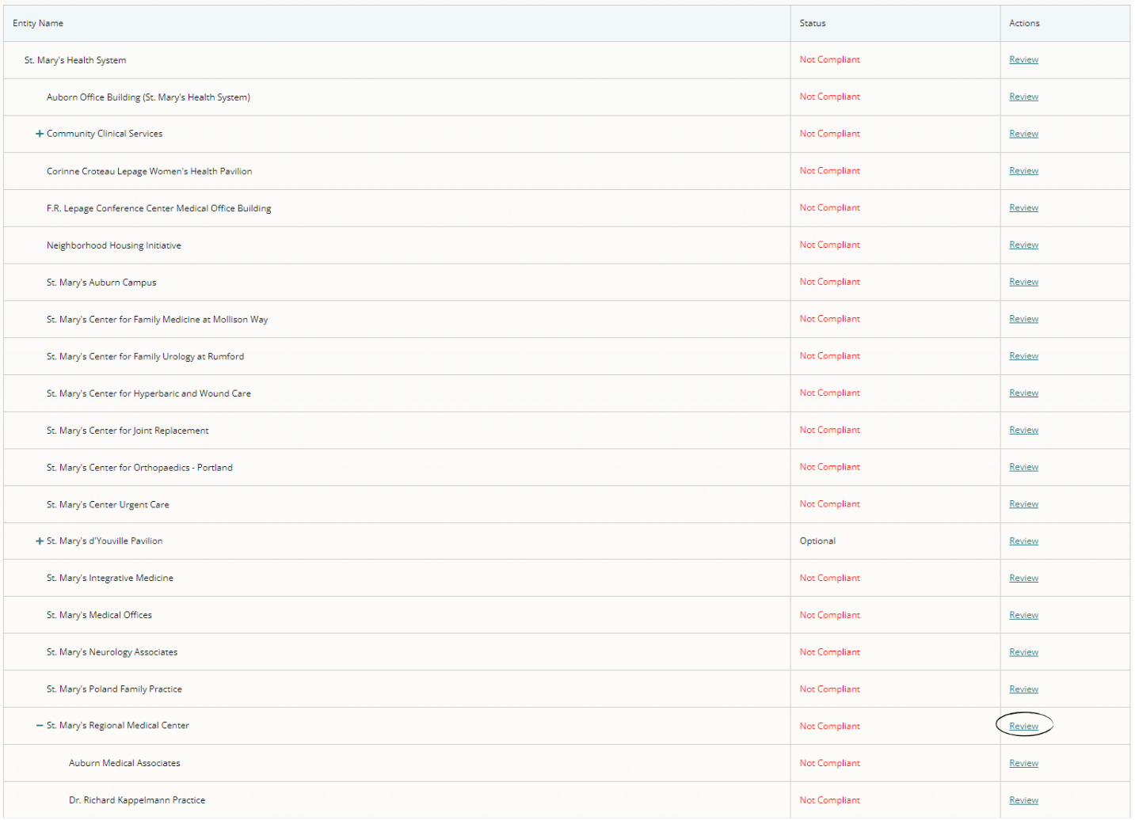

Navigation
You will see breadcrumbs (a text path indicating your location in the portal) at the top of the summary page. These also act as a visual confirmation of the entity that is being reviewed and its affiliated relationships:
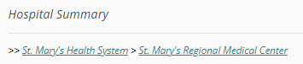

Notifications
The block of information at the top of the page contains:
- Notifications indicating the verification status and if verification is required.
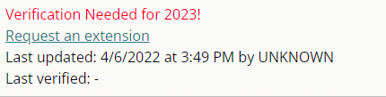
- Date and time stamps for when the information was last updated and verified and by whom.
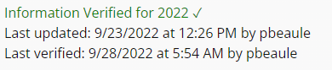
- Link to directly submit a request for an extension through the portal:

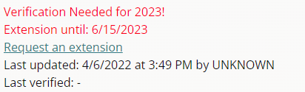
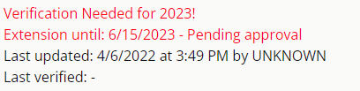
If an extension request has been made, the status will be visible as pending approval or approved:

Details for requesting an extension are on page 25.

Reviewing Organizational Information
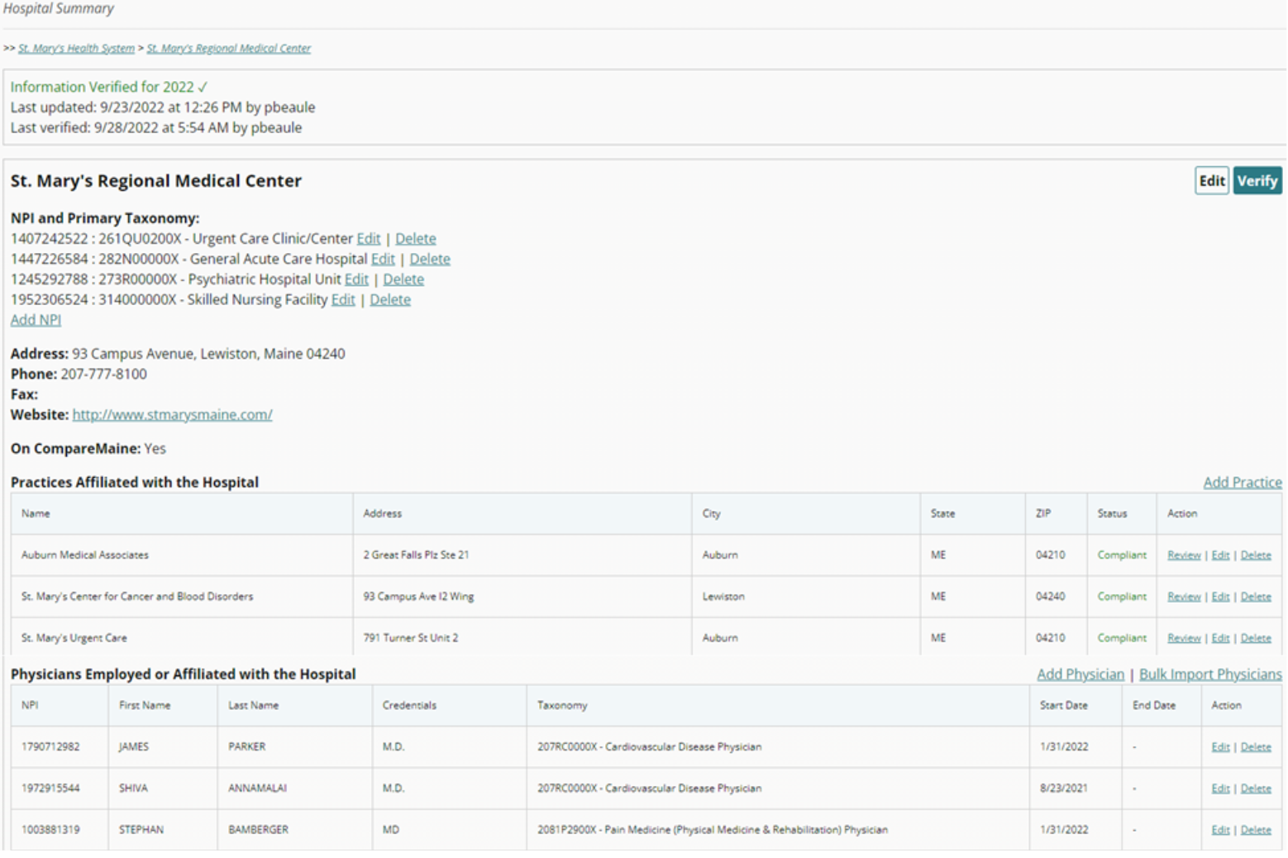
The Hospital Summary looks like this:
Organizational information is displayed for each entity including:
- Entity Name
- Billing NPI(s)
- Primary Taxonomy (for each NPI)
- Address
- Phone
- Fax
- Website
- On CompareMaine
In addition to viewing the information on the summary page, users may scroll down to the “Practices Affiliated with the Hospital” section and click “Review” to see all organizational information for a practice such as physicians employed or affiliated with the practice and any other affiliated practices.

Editing Organizational Information
Clicking “Edit” at the top right of a summary page allows a user to make changes to a health system, parent entity, or hospital’s information:
Except for the billing NPI(s), users can edit most of the entity’s information using the text fields or the drop-down to indicate if the entity is on CompareMaine. Users can “Save” the information or click “Cancel” to return to the previous screen.
After clicking “Save” the notification at the top of the page will be updated to reflect the date and time the information was updated and by whom.
Practices affiliated with a hospital are displayed on the summary page:
Health systems and parent entities may have practices that are associated with them but not affiliated with another entity. When this occurs, the affiliated practices will also be displayed on the summary page:

Adding, Editing, or Deleting NPI(s)
To add a billing NPI associated with the entity, click “Add NPI” on the summary page:
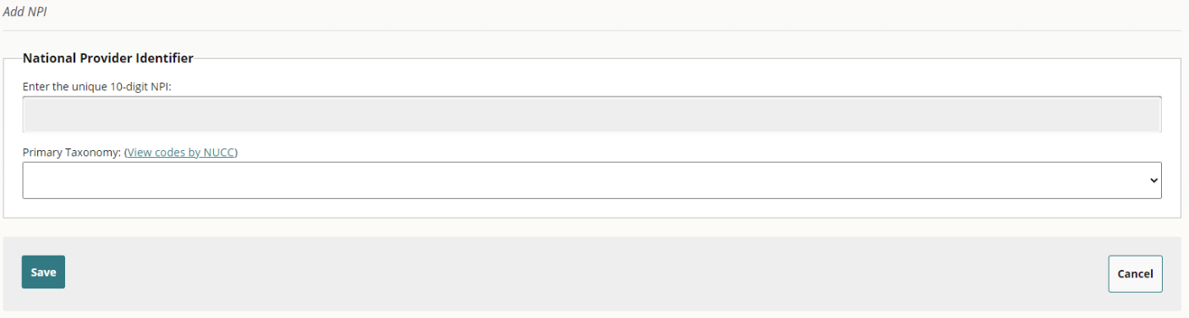
Enter the unique 10-digit NPI code into the text field, use the drop-down to select the Primary Taxonomy associated with the NPI, and “Save” the changes to add the NPI or click “Cancel” to return to the summary page.
The link “View codes by NUCC” allows users to view a PDF to lookup the primary National Uniform Claim Committee (NUCC) health care provider taxonomy code(s) used by the hospital, practice, and employed/affiliated physician.

Edit NPI(s)
Users are unable to directly edit an NPI. If an NPI is incorrect, users must return to the Summary page, delete the NPI, and add the correct NPI.

Delete NPI(s)
To remove an NPI, click “Delete” next to the NPI:
Click “Yes” to confirm removal of the NPI or “No” to return to the summary page.
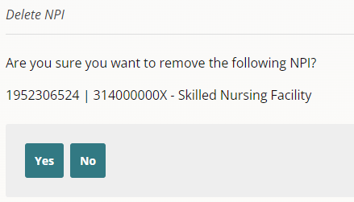

Editing the Primary Taxonomy
To modify a Primary Taxonomy, click “Edit” next to the Taxonomy code and name:
Users may click the drop-down to select a new Primary Taxonomy, “Save” the information, or click “Cancel” to return to the summary page.
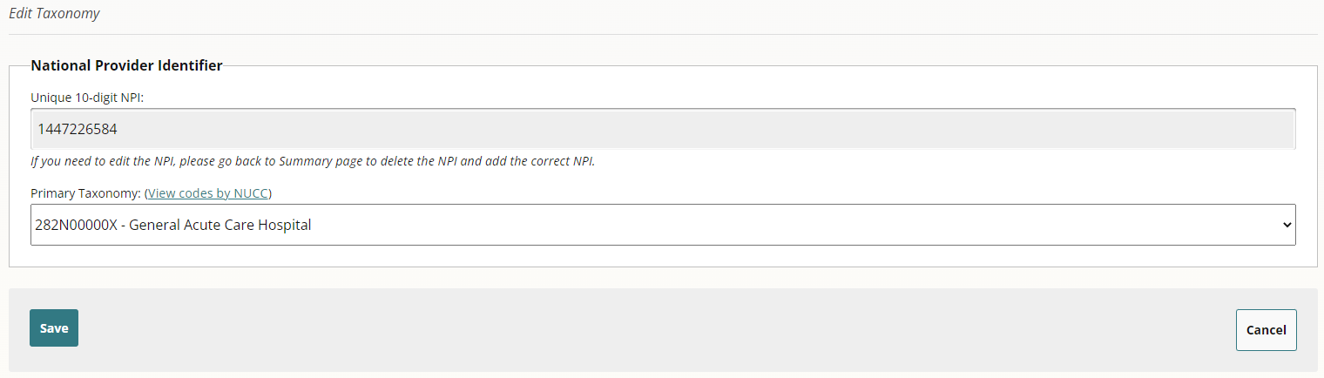

Adding Practices
Click “Add Practice” to add a practice affiliated with a health system, parent entity, or hospital:
Utilize the text fields and drop-downs to complete all required information to add a practice:
- Practice Name
- Billing NPI
- Primary Taxonomy
- Address
- Phone
- Fax
- Website
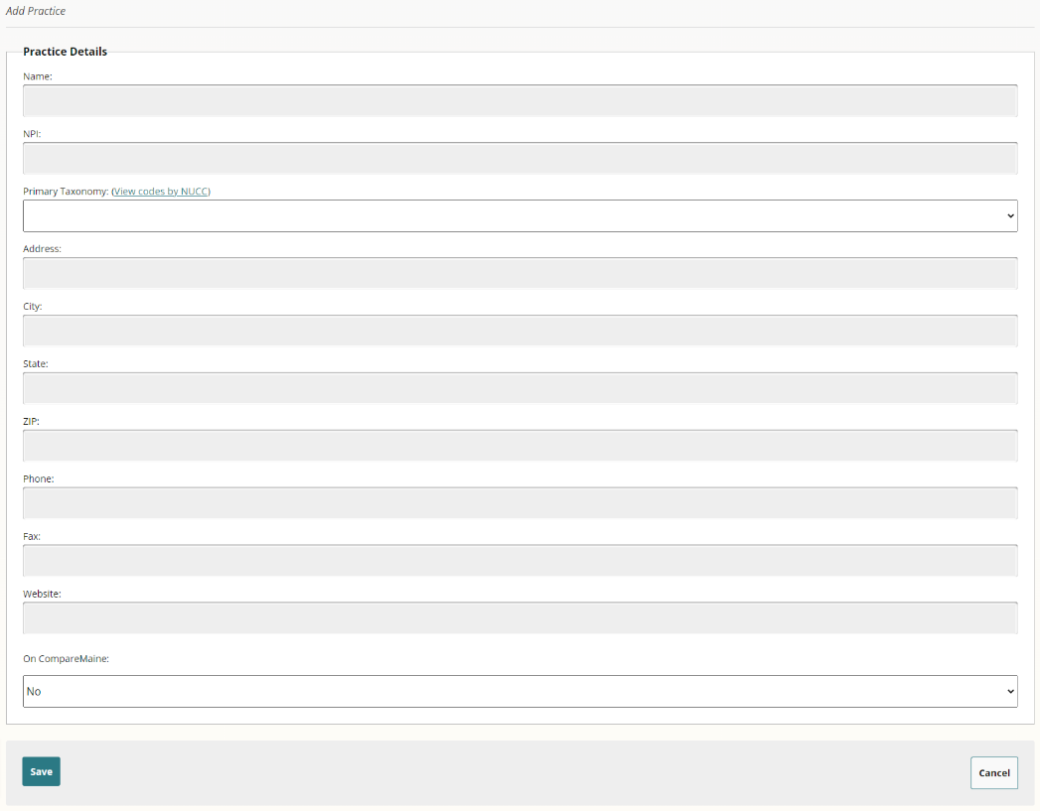
- On CompareMaine
Once complete, users can “Save” the information to have the practice added to the list of affiliated practices or click “Cancel” to return to the previous screen.

Deleting Practices
To remove practices, a user must click “Review” for the health system, parent entity, or hospital:

Then, click “Delete” to remove the practice and its association with the entity:
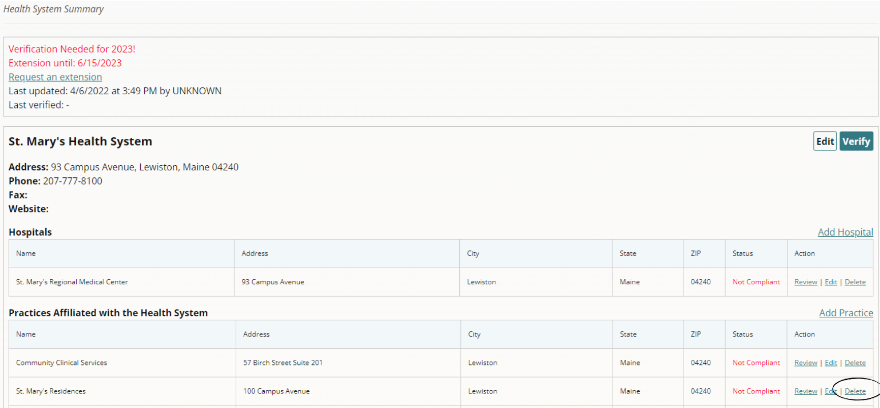

Follow the screen prompts to select the reason for removing the practice:
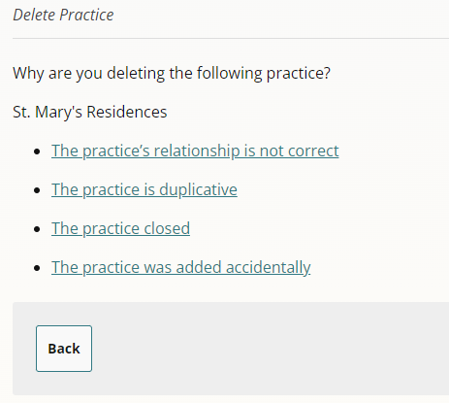
If the practice’s relationship is incorrect, users are asked to complete the following form, for submission to the MHDO Help Desk for review and action:
A practice may need to be renested due to acquisitions, mergers, consolidations, or to correct inaccuracies. The form auto-populates the practice’s name and includes options to select why the relationship is incorrect. If the practice needs to be moved under a different entity, the user must enter the entity’s name in the text box. A text box for comments is required to indicate why the relationship is incorrect. Upon submitting the form, the MHDO Help Desk will receive the information and either contact the user for additional details or confirm that the entity has been moved under the specified entity.
If the practice is duplicative, the user must confirm before deleting the practice:
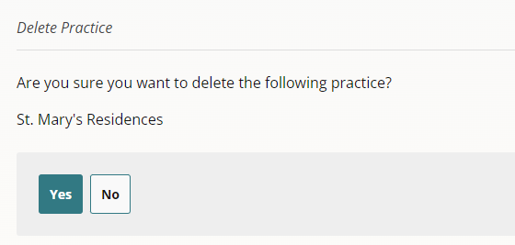
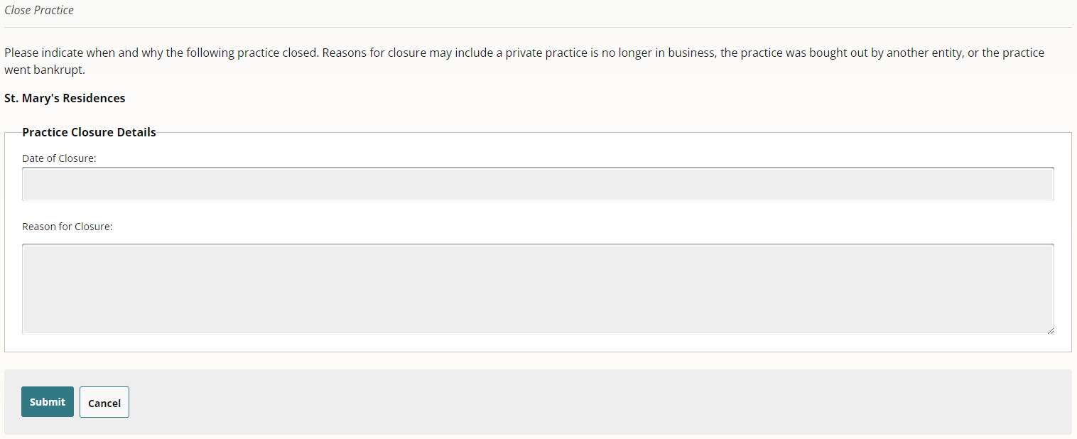
If the practice closed, users must provide the date and reason for the closure. Reasons for closure may include a private practice is no longer in business, the practice was bought out by another entity, or the practice went bankrupt.
If the practice was accidentally added, users must confirm before deleting the practice:
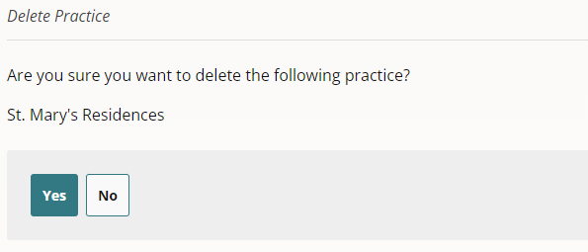
The form will be submitted to the MHDO Help Desk, mhdohelp@hsri.org, and they will follow-up with any questions prior to updating.

Editing Employed or Affiliated Physicians
Clicking on “Edit” next to a physician’s name allows users to edit:
- Rendering NPI
- Prefix
- First Name
- Middle Name
- Last Name
- Suffix
- Credentials
- Primary Taxonomy
- Start Date with the Entity
- End Date with the Entity
Follow the screen prompts to select what you would like to edit:
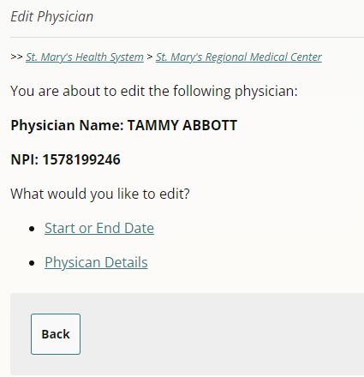
Editing the “Start or End Date” takes users to this screen:
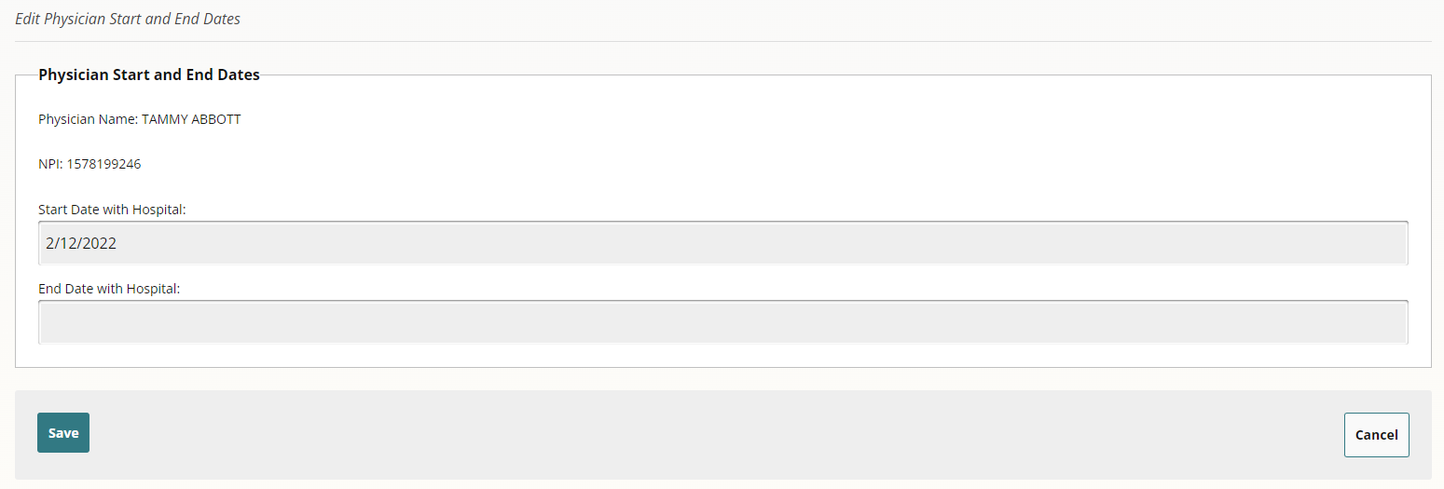
If the physician is employed or affiliated with multiple hospitals or practices, the start and end date is unique to each entity. Future dates, up to 365 days from the current date can be added. The format for start and end dates are mm/dd/yyyy.
Originally, the baseline information in the portal was pre-populated with the start date of 1/31/2022. If this date is still listed, the date needs be updated to accurately reflect the physician’s start date.
Since physicians can be employed or affiliated with multiple hospitals or practices, the MHDO Hospital Data Portal has a separate back-end repository that acts as the sole source of information to ensure that the same physician is not added multiple times but with different spellings of their name. To this point, when a user edits “Physician Details” the updates do not occur immediately; rather, the modifications are sent to the MHDO Help Desk for review, updates, or confirmation. If approved, the physician information is updated in the portal. If declined, or if the updates conflict with other information, MHDO will either make updates or leave the information as-is.

Manually Adding Employed or Affiliated Physicians
A user has a choice of adding physicians one at a time or performing a bulk import when there are several to be added. Clicking “Add Physician” allows users to manually add each physician individually:
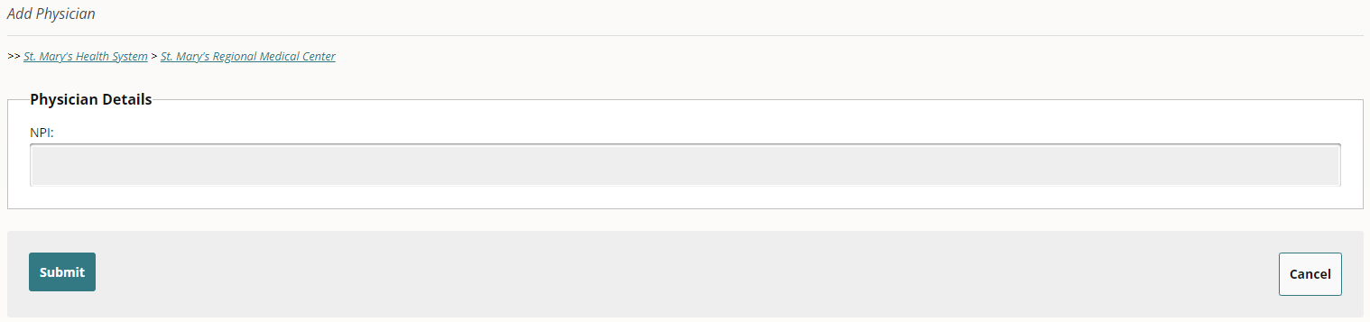
The first step to adding a physician is to enter the unique 10-digit rendering NPI:

Since the MHDO Hospital Data Portal has a back-end repository that acts as the sole source of physician information, if a user enters an NPI that already exists, the physician will appear and the start and end dates, unique to that entity, may be added. Future dates, up to 365 days from the current date can be added in the mm/dd/yyyy format:
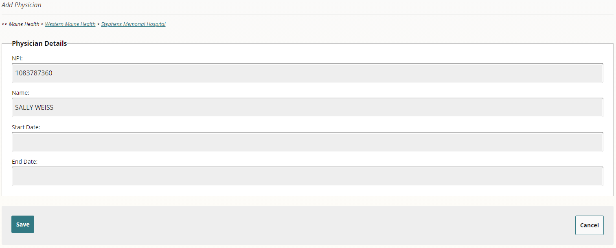
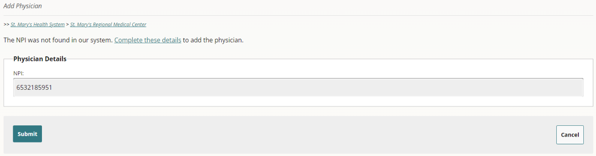
If a user enters an NPI that doesn’t exist, this screen will appear:

Clicking on “Complete these details” allows users to enter the physician’s details:
Clicking “Save” will add the physician to the entity’s list of employed or affiliated physicians and clicking “Cancel” will return the user to the previous screen.

Bulk Importing Employed or Affiliated Physicians
Clicking “Bulk Import Physicians” allows multiple physicians to be added at once:

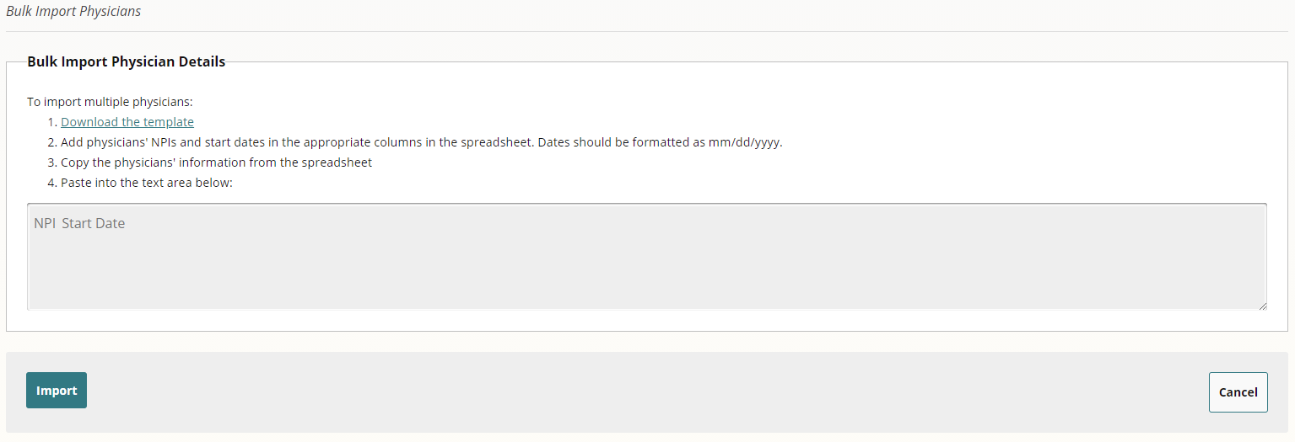
It is important to follow the steps provided on the screen. Begin by selecting the link “Download the template” and open the Microsoft Excel CSV spreadsheet. Using the template, add physicians’ NPIs and start dates in the appropriate columns in the spreadsheet. Format dates as mm/dd/yyyy. Next, copy the physicians’ information from the spreadsheet and paste into the text area on the screen.
Upon clicking “Import,” results are shown that indicate if the physician was successfully found and added in the MHDO Hospital Data Portal database (the separate back-end repository that acts as the sole source of information), or if the physician was not found and needs be added manually:
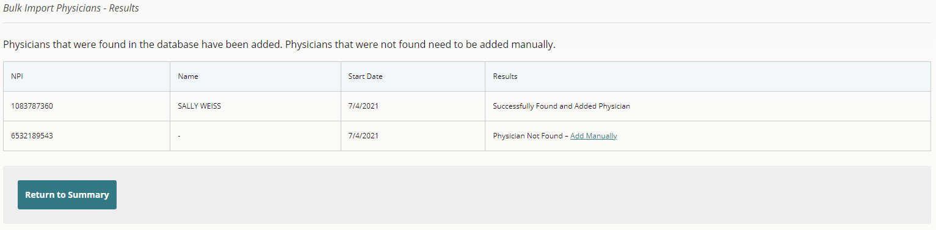
In addition to appearing on the screen, the bulk import results are emailed to the user’s email address for convenience and confirmation.
Clicking “Add Manually” opens a new browser window where the physician details may be added (see section “Manually Adding Employed or Affiliated Physicians on page 21):
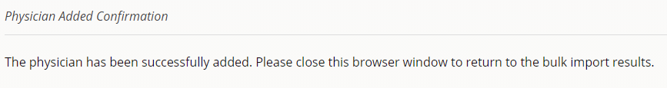
Once the information is added, a user will receive confirmation and be asked to close the browser window to return to the bulk import results:
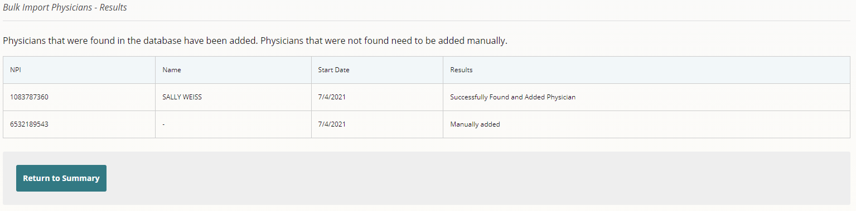
Upon returning to the bulk import results, the newly added physician is shown as being manually added, with their details automatically added to the employed or affiliated physician list:

Adding Affiliated Practices
To add an affiliated practice, clicking “Add Practice” allows users to enter the practice details:
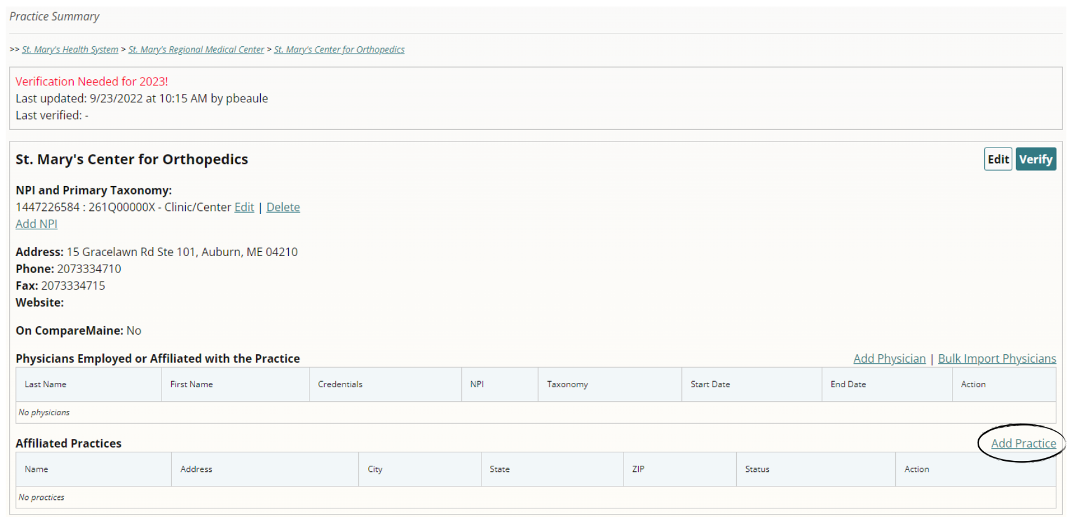
Complete the details on the form to add a practice:
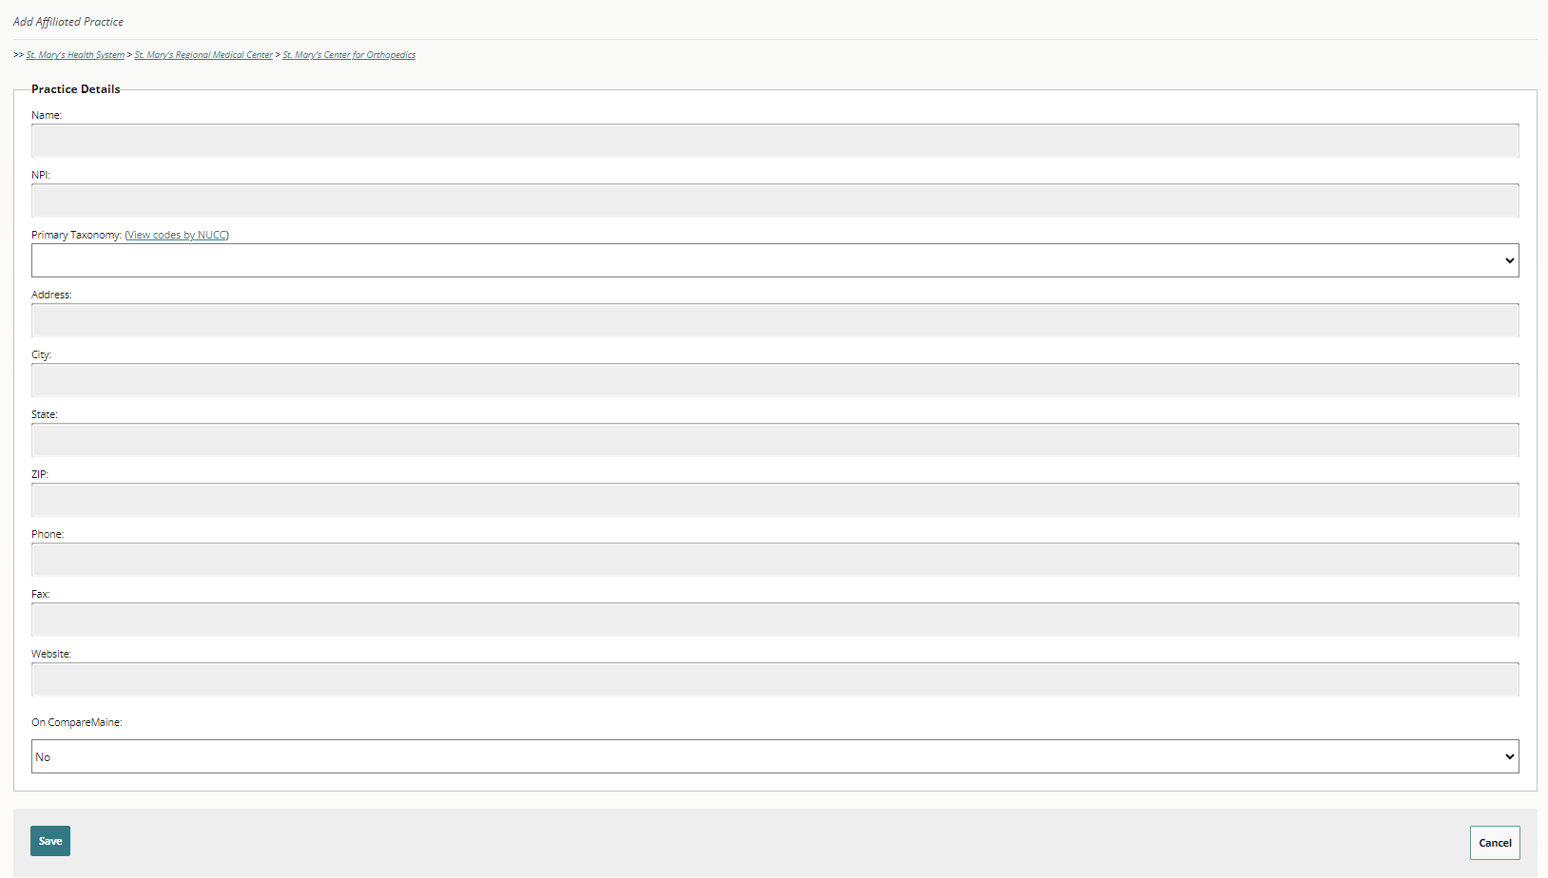
The ZIP Code will display five digits on the summary page, regardless of how many subsequent digits are added.
Clicking “Save” will add the practice and clicking “Cancel” will return the user to the previous screen.
The same process is used to add practices affiliated with a health system or a hospital:
Requesting an Extension
If a health system, parent entity, hospital, and/or any affiliated entities are unable to comply with the requirements to validate organizational information within the allotted timeframe, the entity at the organization’s highest structural level may request an extension by clicking on the “Request an extension” link:

The following form will appear, asking the user to enter the desired expiration date and the reason for the extension request:
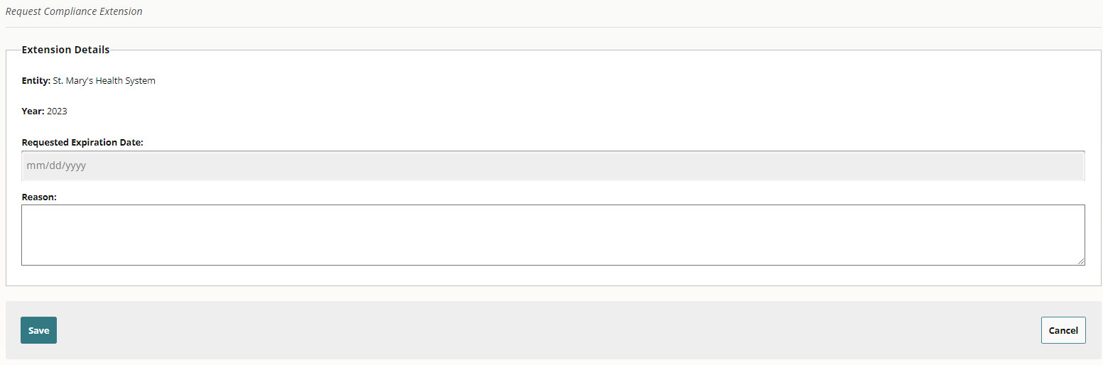
Upon clicking “Save” the extension date will be added to the Health System Summary page as pending approval. MHDO will be notified and will either approve or reject the request for an extension:
Once MHDO approves or rejects the extension request, all users affiliated with the health system, parent entity, and/or hospital will be notified. Although an extension is approved, the status will remain “Not Compliant” until the verifications have been completed.
If the original extension deadline will not be met, an additional extension may be requested:

Final Verification of the Accuracy of the Organization Information
Upon reviewing the accuracy of the entity’s information, including the NPIs and primary taxonomies for each entity, as well as employed or affiliated physicians, click “Verify”.

If you click the “Verify” button but the entity is missing an NPI or Primary Taxonomy, an error message will appear, prompting you to add the information before proceeding with the verification:
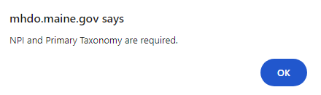
If you click the “Verify” button but the entity is missing any of the related organizational information, an error message will appear, prompting you to add the address, phone number, fax number, website, and if the entity is displayed on CompareMaine:
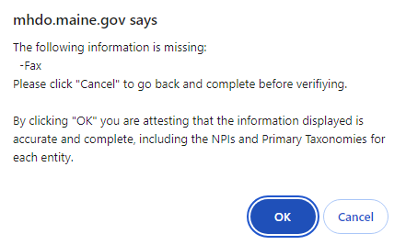
If you click the “Verify” button and there are no physicians listed under the table heading “Physicians Employed or Affiliated with the Hospital/Practice,” you will be redirected to a screen to provide an explanation: or go back to complete the information:
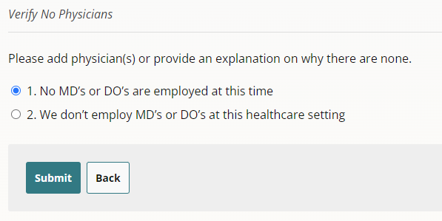
If neither of these options is applicable, you can click “Back” to return to the Summary page to enter physician information.
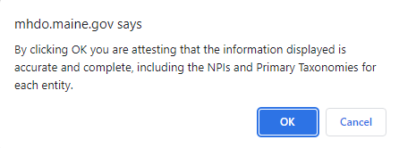
If all organizational information is complete, when clicking the “Verify” button, you will receive the message below:
Once verified, the notification at the top of the page will be updated to reflect the date and time the information was verified and by whom.

Troubleshooting

Technical Support and Completion Help
The MHDO Help Desk is available for any technical/system issue you may experience and to assist in the completion of information. Support is available during regular business hours (8 a.m. – 5 p.m. EST, Monday – Friday). You will receive a call back or an e-mail follow up within two hours of the request.
Toll-free Phone: (866) 451-5876
Email: mhdohelp@hsri.org

Compliance Assistance
Questions relating to deadlines for submission or extension requests can be directed to Debra Dodge, Comprehensive Health Planner II, MHDO: Debra.J.Dodge@maine.gov or (207) 287-6722.

Appendix

Primary Taxonomy Codes and Descriptions
The taxonomy codes utilized are based on the codes identified from the National Uniform Claim Committee (NUCC).

Primary Taxonomy Code | Taxonomy Code Display Name
291U00000X | Clinical Medical Laboratory
333600000X | Pharmacy
3416L0300X | Land Ambulance
282NC0060X | Critical Access Hospital
275N00000X | Medicare Defined Swing Bed Hospital Unit
261QR1300X | Rural Health Clinic/Center
207R00000X | Internal Medicine Physician
2085R0202X | Diagnostic Radiology Physician
363L00000X | Nurse Practitioner
282N00000X | General Acute Care Hospital
310400000X | Assisted Living Facility
273Y00000X | Rehabilitation Hospital Unit
207RG0100X | Gastroenterology Physician
311500000X | Alzheimer Center (Dementia Center)
314000000X | Skilled Nursing Facility
2084P0800X | Psychiatry Physician
207Q00000X | Family Medicine Physician
261QF0400X | Federally Qualified Health Center (FQHC)
367500000X | Certified Registered Nurse Anesthetist
225100000X | Physical Therapist
261QA1903X | Ambulatory Surgical Clinic/Center
174400000X | Specialist
207LP2900X | Pain Medicine (Anesthesiology) Physician
213E00000X | Podiatrist
363LF0000X | Family Nurse Practitioner
101Y00000X | Counselor
101YA0400X | Addiction (Substance Use Disorder) Counselor
363A00000X | Physician Assistant
1223G0001X | General Practice Dentistry
208D00000X | General Practice Physician
1041C0700X | Clinical Social Worker
363LC1500X | Community Health Nurse Practitioner
363LP0200X | Pediatric Nurse Practitioner
152WC0802X | Corneal and Contact Management Optometrist
133V00000X | Registered Dietitian
208000000X | Pediatrics Physician
207V00000X | Obstetrics & Gynecology Physician
207P00000X | Emergency Medicine Physician
313M00000X | Nursing Facility/Intermediate Care Facility
251E00000X | Home Health Agency
251G00000X | Community Based Hospice Care Agency
208600000X | Surgery Physician
261QM0801X | Mental Health Clinic/Center (Including Community Mental Health Center)
251S00000X | Community/Behavioral Health Agency
251B00000X | Case Management Agency
283Q00000X | Psychiatric Hospital
273R00000X | Psychiatric Hospital Unit
207RC0000X | Cardiovascular Disease Physician
207RE0101X | Endocrinology, Diabetes & Metabolism Physician
363AS0400X | Surgical Physician Assistant
2086S0127X | Trauma Surgery Physician
363LA2200X | Adult Health Nurse Practitioner
1223S0112X | Oral and Maxillofacial Surgery (Dentist)
204E00000X | Oral & Maxillofacial Surgery (D.M.D.)
231H00000X | Audiologist
207YX0007X | Plastic Surgery within the Head & Neck (Otolaryngology) Physician
2080P0006X | Developmental - Behavioral Pediatrics Physician
2086S0120X | Pediatric Surgery Physician
207N00000X | Dermatology Physician
2086S0129X | Vascular Surgery Physician
207VE0102X | Reproductive Endocrinology Physician
207W00000X | Ophthalmology Physician
207RC0001X | Clinical Cardiac Electrophysiology Physician
283X00000X | Rehabilitation Hospital
2084N0400X | Neurology Physician
2084N0402X | Neurology with Special Qualifications in Child Neurology Physician
204D00000X | Neuromusculoskeletal Medicine & OMM Physician
104100000X | Social Worker
363AM0700X | Medical Physician Assistant
2080P0202X | Pediatric Cardiology Physician
133NN1002X | Nutrition Education Nutritionist
293D00000X | Physiological Laboratory
156FX1800X | Optician
385H00000X | Respite Care
261QX0203X | Radiation Oncology Clinic/Center
207K00000X | Allergy & Immunology Physician
207L00000X | Anesthesiology Physician
332B00000X | Durable Medical Equipment & Medical Supplies
261QI0500X | Infusion Therapy Clinic/Center
261QR0208X | Mobile Radiology Clinic/Center
261QM2800X | Methadone Clinic
261QE0700X | End-Stage Renal Disease (ESRD) Treatment Clinic/Center
2080P0206X | Pediatric Gastroenterology Physician
261QD0000X | Dental Clinic/Center
261QH0100X | Health Service Clinic/Center
103TP0814X | Psychoanalysis Psychologist
261QM1300X | Multi-Specialty Clinic/Center
207RR0500X | Rheumatology Physician
261QC1500X | Community Health Clinic/Center
101YM0800X | Mental Health Counselor
261QM1200X | Magnetic Resonance Imaging (MRI) Clinic/Center
261QR0200X | Radiology Clinic/Center
261QU0200X | Urgent Care Clinic/Center
273R00000X | Hospital Psychiatric Unit
204R00000X | Electrodiagnostic Medicine Physician
207QS0010X | Sports Medicine (Family Medicine) Physician
207X00000X | Orthopaedic Surgery Physician
207ZB0001X | Blood Banking & Transfusion Medicine Physician
261QP2000X | Physical Therapy Clinic/Center
207RC0200X | Critical Care Medicine (Internal Medicine) Physician
207RP1001X | Pulmonary Disease Physician
261Q00000X | Clinic/Center
103TC0700X | Clinical Psychologist
261QP2300X | Primary Care Clinic/Center
3245S0500X | Children's Substance Abuse Rehabilitation Facility
261QF0050X | Non-Surgical Family Planning Clinic/Center
261QR0401X | Comprehensive Outpatient Rehabilitation Facility (CORF)
103TH0100X | Health Service Psychologist
320800000X | Mental Illness Community Based Residential Treatment Facility
363LW0102X | Women's Health Nurse Practitioner
103G00000X | Clinical Neuropsychologist
207RH0003X | Hematology & Oncology Physician
208200000X | Plastic Surgery Physician
261QM2500X | Medical Specialty Clinic/Center
2086S0105X | Surgery of the Hand (Surgery) Physician
213ES0103X | Foot & Ankle Surgery Podiatrist
320900000X | Intellectual and/or Developmental Disabilities Community Based Residential Treatment Facility
251K00000X | Public Health or Welfare Agency
261QR0405X | Substance Use Disorder Rehabilitation Clinic/Center
171100000X | Acupuncturist
152W00000X | Optometrist
225X00000X | Occupational Therapist
111N00000X | Chiropractor
111NX0800X | Orthopedic Chiropractor
261QR0400X | Rehabilitation Clinic/Center
2085R0001X | Radiation Oncology Physician
1223E0200X | Endodontist
207VG0400X | Gynecology Physician
251300000X | Local Education Agency (LEA)
225XP0200X | Pediatric Occupational Therapist
2085U0001X | Diagnostic Ultrasound Physician
208800000X | Urology Physician
207LC0200X | Critical Care Medicine (Anesthesiology) Physician
122300000X | Dentist
2084A0401X | Addiction Medicine (Psychiatry & Neurology) Physician
111NS0005X | Sports Physician Chiropractor
111NN1001X | Nutrition Chiropractor
302R00000X | Health Maintenance Organization
103T00000X | Psychologist
132700000X | Dietary Manager
235Z00000X | Speech-Language Pathologist
253Z00000X | In Home Supportive Care Agency
252Y00000X | Early Intervention Provider Agency
261QD1600X | Developmental Disabilities Clinic/Center
207XX0005X | Sports Medicine (Orthopaedic Surgery) Physician
207T00000X | Neurological Surgery Physician
3336I0012X | Institutional Pharmacy
363LP0808X | Psychiatric/Mental Health Nurse Practitioner
261QV0200X | VA Clinic/Center
2251S0007X | Sports Physical Therapist
2251X0800X | Orthopedic Physical Therapist
207RG0300X | Geriatric Medicine (Internal Medicine) Physician
1223P0221X | Pediatric Dentist
2251H1200X | Hand Physical Therapist
106H00000X | Marriage & Family Therapist
261QS1000X | Student Health Clinic/Center
101YP2500X | Professional Counselor
335E00000X | Prosthetic/Orthotic Supplier
1223P0300X | Periodontist
207LA0401X | Addiction Medicine (Anesthesiology) Physician
213EP1101X | Primary Podiatric Medicine Podiatrist
305S00000X | Point of Service
261QM0850X | Adult Mental Health Clinic/Center
2080N0001X | Neonatal-Perinatal Medicine Physician
251C00000X | Developmentally Disabled Services Day Training Agency
341600000X | Ambulance
207KA0200X | Allergy Physician
207RA0401X | Addiction Medicine (Internal Medicine) Physician
332H00000X | Eyewear Supplier
1223X0400X | Orthodontics and Dentofacial Orthopedic Dentist
207Y00000X | Otolaryngology Physician
261QX0100X | Occupational Medicine Clinic/Center
207ZP0105X | Clinical Pathology/Laboratory Medicine Physician
390200000X | Student in an Organized Health Care Education/Training Program
367A00000X | Advanced Practice Midwife
251V00000X | Voluntary or Charitable Agency
1223P0700X | Prosthodontist
207QG0300X | Geriatric Medicine (Family Medicine) Physician
207RN0300X | Nephrology Physician
222Z00000X | Orthotist
320600000X | Intellectual and/or Developmental Disabilities Residential Treatment Facility
207WX0108X | Uveitis and Ocular Inflammatory Disease (Ophthalmology) Physician
332BC3200X | Customized Equipment (DME)
213ES0131X | Foot Surgery Podiatrist
323P00000X | Psychiatric Residential Treatment Facility
3104A0625X | Assisted Living Facility (Mental Illness)
133N00000X | Nutritionist
208100000X | Physical Medicine & Rehabilitation Physician
152WL0500X | Low Vision Rehabilitation Optometrist
237700000X | Hearing Instrument Specialist
261QM0855X | Adolescent and Children Mental Health Clinic/Center
225XF0002X | Feeding, Eating & Swallowing Occupational Therapist
208VP0000X | Pain Medicine Physician
322D00000X | Emotionally Disturbed Children’s Residential Treatment Facility
207ZP0102X | Anatomic Pathology & Clinical Pathology Physician
207ND0101X | MOHS-Micrographic Surgery Physician
208M00000X | Hospitalist Physician
2088F0040X | Female Pelvic Medicine and Reconstructive Surgery (Urology) Physician
202K00000X | Phlebology Physician
1223P0106X | Oral and Maxillofacial Pathology Dentist
237600000X | Audiologist-Hearing Aid Fitter
2251P0200X | Pediatric Physical Therapist
122400000X | Denturist
231HA2400X | Assistive Technology Practitioner Audiologist
163WP0809X | Adult Psychiatric/Mental Health Registered Nurse
311ZA0620X | Adult Care Home Facility
320700000X | Physical Disabilities Residential Treatment Facility
175F00000X | Naturopath
224Z00000X | Occupational Therapy Assistant
305R00000X | Preferred Provider Organization
225700000X | Massage Therapist
111NN0400X | Neurology Chiropractor
363LX0001X | Obstetrics & Gynecology Nurse Practitioner
176B00000X | Midwife
343900000X | Non-emergency Medical Transport (VAN)
208C00000X | Colon & Rectal Surgery Physician
103TC2200X | Clinical Child & Adolescent Psychologist
124Q00000X | Dental Hygienist
207RA0000X | Adolescent Medicine (Internal Medicine) Physician
152WV0400X | Vision Therapy Optometrist
2082S0105X | Surgery of the Hand (Plastic Surgery) Physician
103TH0004X | Health Psychologist
261QP3300X | Pain Clinic/Center
284300000X | Special Hospital
261QS0132X | Ophthalmologic Surgery Clinic/Center
156FX1700X | Ocularist
376G00000X | Nursing Home Administrator
315P00000X | Intellectual Disabilities Intermediate Care Facility
3104A0630X | Assisted Living Facility (Behavioral Disturbances)
253J00000X | Foster Care Agency
3747P1801X | Personal Care Attendant
222Q00000X | Developmental Therapist
171M00000X | Case Manager/Care Coordinator
3416A0800X | Air Ambulance
224P00000X | Prosthetist
261QA0600X | Adult Day Care Clinic/Center
324500000X | Substance Abuse Rehabilitation Facility
103K00000X | Behavioral Analyst
311Z00000X | Custodial Care Facility
183500000X | Pharmacist
251J00000X | Nursing Care Agency
364SL0600X | Long-Term Care Clinical Nurse Specialist
261QP0905X | State or Local Public Health Clinic/Center
2086S0122X | Plastic and Reconstructive Surgery Physician
310500000X | Mental Illness Intermediate Care Facility
207RI0200X | Infectious Disease Physician
261QS0112X | Oral and Maxillofacial Surgery Clinic/Center
103TM1800X | Intellectual & Developmental Disabilities Psychologist
335V00000X | Portable X-ray and/or Other Portable Diagnostic Imaging Supplier
171W00000X | Contractor
302F00000X | Exclusive Provider Organization
146N00000X | Basic Emergency Medical Technician
146L00000X | Paramedic
224900000X | Mastectomy Fitter
2255A2300X | Athletic Trainer
103TC1900X | Counseling Psychologist
364SP0808X | Psychiatric/Mental Health Clinical Nurse Specialist
3336C0003X | Community/Retail Pharmacy
2084P0804X | Child & Adolescent Psychiatry Physician

